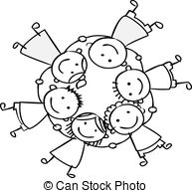

Name: _______________________________
Mrs.Zimmerman, Teacher
2 0 1 9 – 2 0 2 0

fox hills elementary

My third grade

data book

Dibels Reading
 | Fluency  BOY | Composite  BOY | Fluency  MOY | Composite  MOY | Fluency  EOY | Composite  EOY
Goals: BOY | Higher | Higher | Higher | Higher | Higher | Higher
Fluency: 70 wpm or more | 160 | 400 | 160 | 400 | 160 | 400
Composite: 220 or more | 155 | 390 | 155 | 390 | 155 | 390
 | 150 | 380 | 150 | 380 | 150 | 380
Goals: MOY | 145 | 370 | 145 | 370 | 145 | 370
Fluency: 86 wpm or more | 140 | 360 | 140 | 360 | 140 | 360
Composite: 285 or more | 135 | 350 | 135 | 350 | 135 | 350
 | 130 | 340 | 130 | 340 | 130 | 340
Goals: EOY | 125 | 330 | 125 | 330 | 125 | E 330
Fluency: 100 wpm or more | 120 | 320 | 120 | 320 | 120 | 320
Composite: 325 or more | 115 | 310 | 115 | 310 | 115 | 310
 | 110 | 300 | 110 | 300 | 110 | 300
 | 105 | 290 | 105 | 290 | 105 | 290
 | 100 | 280 | 100 | M 280 | E 100 | 280
 | 95 | 270 | 95 | 270 | 95 | 270
 | 90 | 260 | 90 | 260 | 90 | 260
 | 85 | 250 | M 85 | 250 | 85 | 250
 | 80 | 240 | 80 | 240 | 80 | 240
 | 75 | 230 | 75 | 230 | 75 | 230
 | B 70 | B 220 | 70 | 220 | 70 | 220
 | 65 | 210 | 65 | 210 | 65 | 210
 | 60 | 200 | 60 | 200 | 60 | 200
 | 55 | 190 | 55 | 190 | 55 | 190
 | 50 | 180 | 50 | 180 | 50 | 180
 | 45 | 170 | 45 | 170 | 45 | 170
 | 40 | 160 | 40 | 160 | 40 | 160
 | 35 | 150 | 35 | 150 | 35 | 150
 | 30 | 140 | 30 | 140 | 30 | 140
 | 25 | 130 | 25 | 130 | 25 | 130
 | 20 | 120 | 20 | 120 | 20 | 120
 | 15 | 110 | 15 | 110 | 15 | 110
 | 10 | 100 | 10 | 100 | 10 | 100
 | 5 | 90 | 5 | 90 | 5 | 90
 | 0 | 80 | 0 | 80 | 0 | 80

DAZE Reading
3 minute timed test. Record your score.
Score = number correct minus 1 point for every 2 errors.
Practice Test # | Score | Practice Test # | Score
1 |  | 11
2 |  | 12
3 |  | 13
4 |  | 14
5 |  | 15
6 |  | 16
7 |  | 17
8 |  | 18
9 |  | 19
10 |  | 20

DAZE | Score
BOY Test Goal: 8
MOY Test Goal: 11
EOY Test Goal: 19
A LOOK AT PERCENTS:
Percent | Grade | What it means
90 - 100 | A | A
80 - 89 | B | m
70 - 79 | C | Z
60 - 69 | D | g
50 – 0 | N | h
SCHOOL CITY MATH Pre & Post Tests –
Benchmarks 3rd Grade
% |  |  | % | % |  |  | % | % |  |  | %
100 |  |  | 100 | 100 |  |  | 100 | 100 |  |  | 100
96 |  |  | 96 | 96 |  |  | 96 | 96 |  |  | 96
92 |  |  | 92 | 92 |  |  | 92 | 92 |  |  | 92
88 |  |  | 88 | 88 |  |  | 88 | 88 |  |  | 88
84 |  |  | 84 | 84 |  |  | 84 | 84 |  |  | 84
80 |  |  | 80 | 80 |  |  | 80 | 80 |  |  | 80
76 |  |  | 76 | 76 |  |  | 76 | 76 |  |  | 76
72 |  |  | 72 | 72 |  |  | 72 | 72 |  |  | 72
68 |  |  | 68 | 68 |  |  | 68 | 68 |  |  | 68
64 |  |  | 64 | 64 |  |  | 64 | 64 |  |  | 64
60 |  |  | 60 | 60 |  |  | 60 | 60 |  |  | 60
56 |  |  | 56 | 56 |  |  | 56 | 56 |  |  | 56
52 |  |  | 52 | 52 |  |  | 52 | 52 |  |  | 52
48 |  |  | 48 | 48 |  |  | 48 | 48 |  |  | 48
44 |  |  | 44 | 44 |  |  | 44 | 44 |  |  | 44
40 |  |  | 40 | 40 |  |  | 40 | 40 |  |  | 40
36 |  |  | 36 | 36 |  |  | 36 | 36 |  |  | 36
32 |  |  | 32 | 32 |  |  | 32 | 32 |  |  | 32
28 |  |  | 28 | 28 |  |  | 28 | 28 |  |  | 28
24 |  |  | 24 | 24 |  |  | 24 | 24 |  |  | 24
20 |  |  | 20 | 20 |  |  | 20 | 20 |  |  | 20
16 |  |  | 16 | 16 |  |  | 16 | 16 |  |  | 16
12 |  |  | 12 | 12 |  |  | 12 | 12 |  |  | 12
8 |  |  | 8 | 8 |  |  | 8 | 8 |  |  | 8
4 |  |  | 4 | 4 |  |  | 4 | 4 |  |  | 4
 | A Pre | A Post |  |  | B Pre | B Post |  |  | C Pre | C Post
SCHOOL CITY LA Pre & Post Tests –
Benchmarks 3rd Grade
% |  |  | % | % |  |  | % | % |  |  | %
100 |  |  | 100 | 100 |  |  | 100 | 100 |  |  | 100
96 |  |  | 96 | 96 |  |  | 96 | 96 |  |  | 96
92 |  |  | 92 | 92 |  |  | 92 | 92 |  |  | 92
88 |  |  | 88 | 88 |  |  | 88 | 88 |  |  | 88
84 |  |  | 84 | 84 |  |  | 84 | 84 |  |  | 84
80 |  |  | 80 | 80 |  |  | 80 | 80 |  |  | 80
76 |  |  | 76 | 76 |  |  | 76 | 76 |  |  | 76
72 |  |  | 72 | 72 |  |  | 72 | 72 |  |  | 72
68 |  |  | 68 | 68 |  |  | 68 | 68 |  |  | 68
64 |  |  | 64 | 64 |  |  | 64 | 64 |  |  | 64
60 |  |  | 60 | 60 |  |  | 60 | 60 |  |  | 60
56 |  |  | 56 | 56 |  |  | 56 | 56 |  |  | 56
52 |  |  | 52 | 52 |  |  | 52 | 52 |  |  | 52
48 |  |  | 48 | 48 |  |  | 48 | 48 |  |  | 48
44 |  |  | 44 | 44 |  |  | 44 | 44 |  |  | 44
40 |  |  | 40 | 40 |  |  | 40 | 40 |  |  | 40
36 |  |  | 36 | 36 |  |  | 36 | 36 |  |  | 36
32 |  |  | 32 | 32 |  |  | 32 | 32 |  |  | 32
28 |  |  | 28 | 28 |  |  | 28 | 28 |  |  | 28
24 |  |  | 24 | 24 |  |  | 24 | 24 |  |  | 24
20 |  |  | 20 | 20 |  |  | 20 | 20 |  |  | 20
16 |  |  | 16 | 16 |  |  | 16 | 16 |  |  | 16
12 |  |  | 12 | 12 |  |  | 12 | 12 |  |  | 12
8 |  |  | 8 | 8 |  |  | 8 | 8 |  |  | 8
4 |  |  | 4 | 4 |  |  | 4 | 4 |  |  | 4
 | A Pre | A Post |  |  | B Pre | B Post |  |  | C Pre | C Post

GO MATH PERCENTAGES
 | Attempt 1 | Attempt 2 |  | Attempt 1 | Attempt 2
Chapter 1 Vocabulary  42: L3.6 |  |  | Ch 1 Mid Ch √ pt
 |  |  | Chapter 1 Test
Chapter 2 Vocabulary  42: L3.6 |  |  | Ch 2 Mid Ch √ pt
 |  |  | Chapter 2 Test
Chapter 3 Vocabulary  42: L3.6 |  |  | Ch 3 Mid Ch √ pt
 |  |  | Chapter 3 Test
Chapter 4 Vocabulary  42: L3.6 |  |  | Ch 4 Mid Ch √ pt
 |  |  | Chapter 4 Test
Chapter 5 Vocabulary  42: L3.6 |  |  | Ch 5 Mid Ch √ pt
 |  |  | Chapter 5 Test
Chapter 6 Vocabulary  42: L3.6 |  |  | Ch 6 Mid Ch √ pt
 |  |  | Chapter 6 Test
Chapter 7 Vocabulary  42: L3.6 |  |  | Ch 7 Mid Ch √ pt
 |  |  | Chapter 7 Test
Chapter 8 Vocabulary  42: L3.6 |  |  | Ch 8 Mid Ch √ pt
 |  |  | Chapter 8 Test
Chapter 9 Vocabulary  42: L3.6 |  |  | Ch 9 Mid Ch √ pt
 |  |  | Chapter 9 Test
Chapter 10 Vocabulary  42: L3.6 |  |  | Ch 10 Mid Ch √ pt
 |  |  | Chapter 10 Test
Chapter 11 Vocabulary  42: L3.6 |  |  | Ch 11 Mid Ch √ pt
 |  |  | Chapter 11 Test
Chapter 12 Vocabulary  42: L3.6 |  |  | Ch 12 Mid Ch √ pt
 |  |  | Chapter 12 Test

Spelling Test Percentages
38: L3.2E
Review A |  | 4.2
1.1 |  | 4.3
1.2 |  | 4.4
1.3 |  | 4.5
1.4 |  | 5.1
1.5 |  | 5.2
2.1 |  | 5.3
2.2 |  | 5.4
2.3 |  | 5.5
2.4 |  | 6.1
2.5 |  | 6.2
3.1 |  | 6.3
3.2 |  | 6.4
3.3 |  | 6.5
3.4 |  | Review B
3.5 |  | Review C
4.1 |  | Review D
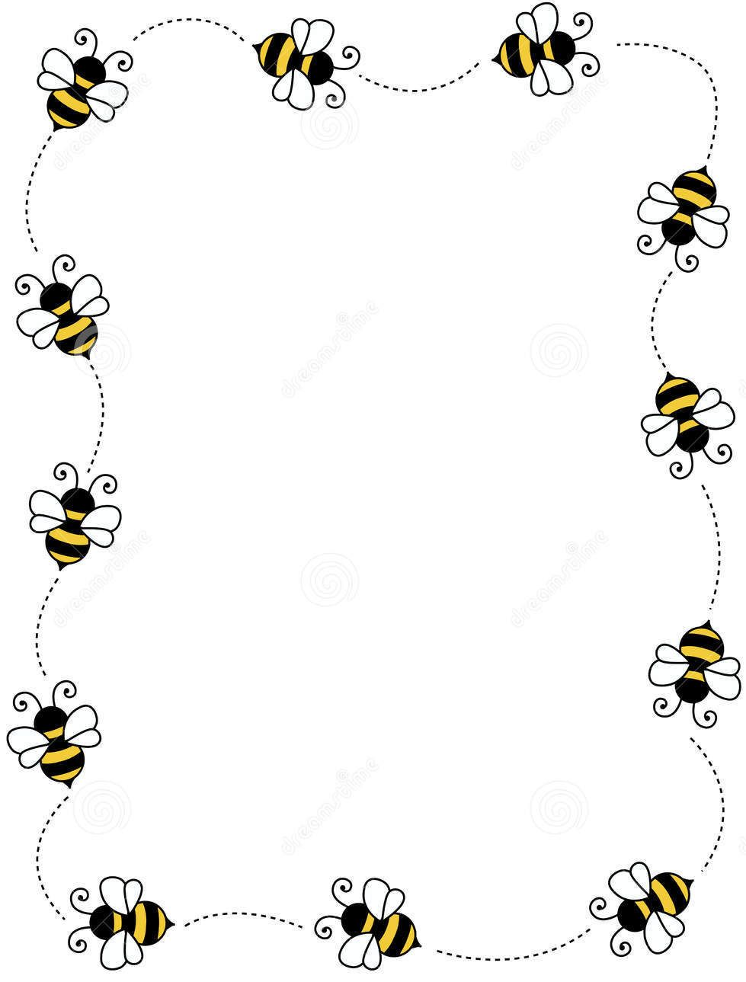
WONDERS
32: SL3.2 LISTENING COMPREHENSION QUIZZES
Quiz # | Score | Quiz # | Score | Quiz # | Score
1.1 |  | 3.1 |  | 5.1
1.2 |  | 3.2 |  | 5.2
1.3 |  | 3.3 |  | 5.3
1.4 |  | 3.4 |  | 5.4
1.5 |  | 3.5 |  | 5.5
2.1 |  | 4.1 |  | 6.1
2.2 |  | 4.2 |  | 6.2
2.3 |  | 4.3 |  | 6.3
2.4 |  | 4.4 |  | 6.4
2.5 |  | 4.5 |  | 6.5
42: L3.6 Wonders
Vocabulary Quizzes
Quiz | Score | Quiz | Score
1.1 |  | 4.1
1.2 |  | 4.2
1.3 |  | 4.3
1.4 |  | 4.4
1.5 |  | 4.5
2.1 |  | 5.1
2.2 |  | 5.2
2.3 |  | 5.3
2.4 |  | 5.4
2.5 |  | 5.5
3.1 |  | 6.1
3.2 |  | 6.2
3.3 |  | 6.3
3.4 |  | 6.4
3.5 |  | 6.5
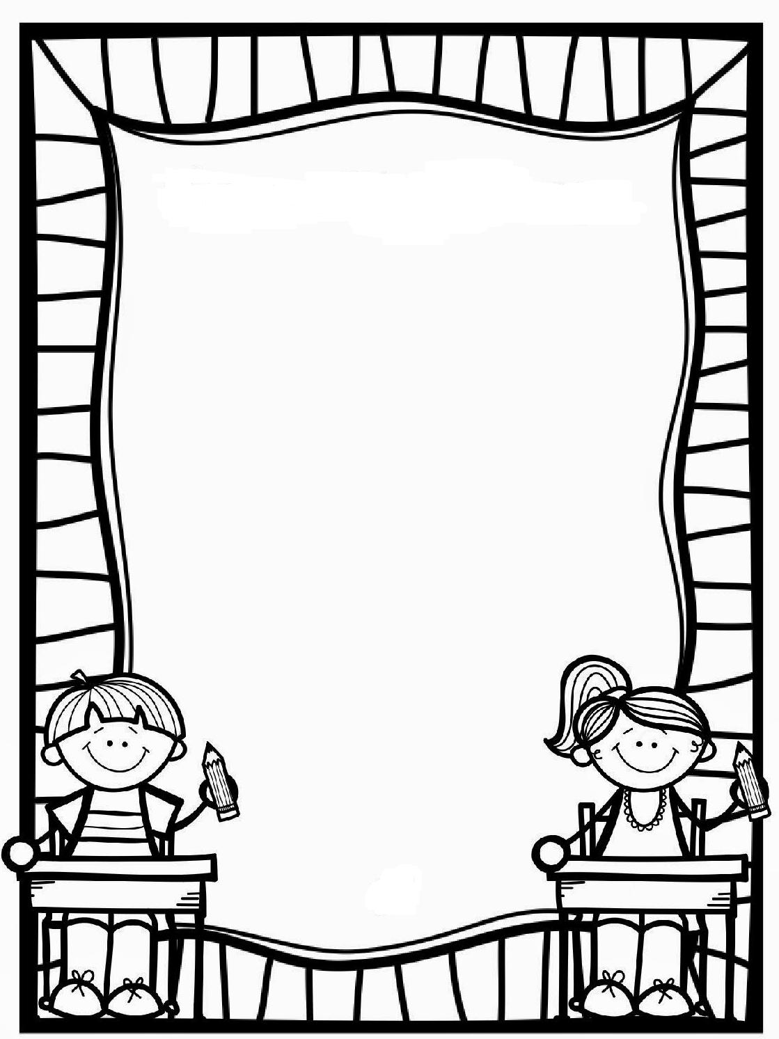
MATH Core  Standard  Number | Description | Attempt 1 | Attempt 2 | Attempt 3
1  Operations and Algebraic Thinking | 3.0A.1 Multiplication as equal groups and number in each group
2 | 3.OA.2 Division as partitive and quotative
3 | 3.OA.3 Multiplication word problems
4 | 3.OA.4 Find the unknown number
5 | 3.OA.5 Properties of multiplication and division
6 | 3.OA.6 Division as an unknown factor problem
7 | 3.OA.7 Memorize multiplication facts
8 | 3.OA.8 Solve two-step problems
9 | 3.OA.8a Solve two-step problems using Order of Operations
10 | 3.OA.9 Identify patterns
11  Base Ten | 3.NBT.1 Round numbers to nearest 10 or 100
12 | 3.NBT.2 Fluently add and subtract with 1,000
13 | 3.NBT.3 Multiples of 10
14  Numbers and Operations - Fractions | 3.NF.1 Unit fractions
15 | 3.NF.1a: 1/b is one part when a whole is divided into b parts
16 | 3.NF.1b: a/b as a parts of 1/b size
17 | 3.NF.2 Fractions on a number line
18 | 3.NF.2a: Find 1/b on a number line
19 | 3.NF.2b: Find a/b on a number line
20 | 3.NF.3 Explain equivalent fractions
MATH Core  Standard  Number | Description | Attempt 1 | Attempt 2 | Attempt 3
21  Fractions | 3.NF.3a: Equivalent fractions have same size or are at the same point on a number line.
22 | 3.NF.3b: Make simple equivalent fractions
23 | 3.NF.3c: Write whole numbers as fractions
24 | 3.NF.3d: Compare fractions with same numerator or same denominator
25  Measurement and Data | 3.MD.1 Time to the minute and measure time intervals
26 | 3.MD.2 Solve one-step word problems with liquid volume and mass
27 | 3.MD.3 Draw picture graph and bar graph.
28 | 3.MD.4 Measure using rulers and make line plots
29 | 3.MD.5 Area as attribute of flat figures
30 | 3.MD.5a: Unit squares to measure area
31 | 3.MD.5b: n unit squares = n square units
32 | 3.MD.6 Area by counting unit squares
33 | 3.MD.7 Relate area to multiplication and addition
34 | 3.MD.7a: Find area by multiplying length and width
35 | 3.MD.7b: Solve real-world area problems
36 | 3.MD.7c: Use distributive property to figure out the area
37 | 3.MD.7d: Area as additive
38 | 3.MD.8 Real world problems with perimeter
39  Geometry | 3.G.1 Categorizing shapes, incl. quadrilaterals
40 | 3.G.2 Break shapes into parts with equal areas
LA Core Standard  Number | Description | Attempt 1 | Attempt 2 | Attempt 3
1  READING: FOUNDATIONAL SKILLS  SKILLS | RF3.3 Know and apply grade level phonics and word analysis skills in decoding words | X | X | X
 | RF3.3A Prefixes and Suffixes
 | RF3.3B Latin Suffixes
 | RF3.3C Know and apply grade level phonics and word analysis skills in decoding words. Decode multi-syllabic words.
 | RF3.3D Read irregularly spelled words
2 | RF3.4 Read with sufficient accuracy and fluency to support comprehension | X | X | X
 | RF.3.4.A Read grade level text with purpose and understanding
 | RF.3.4.B Read grade level prose and poetry orally with accuracy, appropriate rate, and expression on successive readings
 | RF.3.4.C Use context to confirm or self-correct word recognition and understanding, rereading as necessary
3  READING: LITERATURE | RL3.1 Ask and answer questions to demonstrate understanding of a text, referring explicitly to the text as the basis for the answers
4 | RL3.2 Recount stories, including fables, folktales, and myths from diverse cultures; determine the central message, lesson, or moral and explain how it is conveyed through key details in the text
5 | RL3.3 Describe characters in a story (e.g., their traits, motivations, or feelings) and explain how their actions contribute to the sequence of events
6 | RL3.4 Determine the meaning of words and phrases as they are used in a text, distinguishing literal from non-literal language
7 | RL3.5 Refer to parts of stories, dramas, and poems when writing or speaking about a text, using terms such as chapter, scene, and stanza; describe how each successive part builds on earlier sections
8 | RL3.6 Distinguish their own point of view from that of the narrator or those of the characters
9 | RL3.7 Explain how specific aspects of a text’s illustrations contribute to what is conveyed by the words in a story (e.g., create mood, emphasize aspects of a character or setting)
10 | RL3.9 Compare and contrast the themes, settings, and plots of stories written by the same author about the same or similar characters (e.g., in books from a series)
11 | RL3.10 By the end of the year, read and comprehend literature, including stories, dramas, and poetry, at the high end of the grades 2-3 text complexity band independently and proficiently
LA Core Standard  Number | Description | Attempt 1 | Attempt 2 | Attempt 3
READING: INFORMATIONAL TEXTS  12 | RI3.1 Ask and answer questions to demonstrate understanding of a text, referring explicitly to the text as the basis for the answers
13 | RI3.2 Determine the main idea of a text; recount the key details and explain how they support the main idea
14 | RI3.3 Describe the relationship between a series of historical events, scientific ideas or concepts, or steps in technical procedures in a text, using language that pertains to time, sequence, and cause/effect
15 | RI3.4 Determine the meaning of general academic and domain specific words and phrases in a text relevant to a grade 3 topic or subject area
16 | RI3.5 Use text features and search tools (e.g., key words, sidebars, hyperlinks) to locate information relevant to a given topic efficiently
17 | RI3.6 Distinguish their own point of view from that of the author or text
18 | RI3.7 Use information gained from illustrations (e.g., maps, photographs) and the words in a text to demonstrate understanding of the text (e.g., where, when, why, and how key events occur)
19 | RI3.8 Describe the logical connection between particular sentences and paragraphs in a text (e.g., comparison, cause/effect, first/second/third in a sequence)
20 | RI3.9 Compare and contrast the most important points and key details presented in two texts on the same topic
21 | RI3.10 By the end of the year, read and comprehend informational texts, including history/social studies, science, and technical texts, at the high end of grades 2-3 text complexity band independently and proficiently
22  WRITING STANDARDS | W3.1 Write opinion pieces on topics or texts, supporting a point of view with reasons. | X | X | X
 | W3.1A Create an organizational structure for opinion piece
 | W3.1B Provide reasons that support opinion
 | W3.1C Use linking words and phrases to connect opinions and reasons
 | W3.1D Provide a concluding statement
23 | W3.2 Write informative/explanatory texts to examine a topic and convey ideas and information clearly. | X | X | X
 | W3.2A Group related information together; provide illustrations
 | W3.2B Develop topic with facts, definitions, and details
 | W3.2C Use linking words and phrases to connect
 | W3.2D Provide a concluding statement
LA Core Standard  Number | Description | Attempt 1 | Attempt 2 | Attempt 3
24  WRITING STANDARDS | W3.3 Write narratives to develop real or imagined experiences or events using effective technique, descriptive details, and clear event sequences. | X | X | X
 | W3.3A Establish a situation & introduce characters and/or narrator
 | W3.3B Use dialogue & descriptions to develop story
 | W3.3C Use temporal words and phrases
 | W3.3D Provide a sense of closure
25 | W3.4 With guidance and support from adults, produce writing in which the development and organization are appropriate to task and purpose.
26 | W3.5 With guidance and support from peers and adults, develop and strengthen writing as needed by planning, revising, and editing.
27 | W3.6 With guidance and support from adults, use technology to produce and publish writing (using keyboarding skills) as well as to interact and collaborate with others.
28 | W3.7 Conduct short research projects that build knowledge about a topic.
29 | W3.8 Recall information from experiences or gather information from print and digital sources; take brief notes on sources and sort evidence into provided categories.
30 | W3.10 Write routinely over extended time frames (time for research, reflection, and revision) and shorter time frames (a single sitting or a day or two) for a range of discipline-specific tasks, purposes, and audiences.
31  SPEAKING AND LISTENING | SL3.1 Engage effectively in a range of collaborative discussions (one-on-one, in groups, and teacher-led) with diverse partners on grade 3 topics and texts, building on others’ ideas and expressing their own clearly | X | X | X
 | SL3.1A Come to discussions prepared to explore ideas
 | SL3.1B Follow agreed-upon rules for discussion
 | SL3.1C Ask questions
 | SL3.1D Explain their own ideas & understanding
LA Core Standard  Number | Description | Attempt 1 | Attempt 2 | Attempt 3
33  SPEAKING AND LISTENING | SL3.3 Ask and answer questions about information from a speaker, offering appropriate elaboration and detail
34 | SL3.4 Report on a topic or text, tell a story, or recount an experience with appropriate facts and relevant, descriptive details, speaking clearly at an understandable pace
35 | SL3.5 Create engaging audio recordings of stories or poems that demonstrate fluid reading at an understandable pace; add visual displays when appropriate to emphasize or enhance certain facts or details
36 | SL3.6 Speak in complete sentences when appropriate to task and situation in order to provide requested detail or clarification
37  ENGLISH/LANGUAGE ARTS STANDARDS | L3.1 Demonstrate command of the conventions of standard English grammar and usage when writing or speaking | X | X | X
 | L3.1A Explain nouns, pronouns, verbs, adjectives, and adverbs
 | L3.1B Use regular and irregular plural nouns
 | L3.1C Use abstract nouns
 | L3.1D Use regular and irregular verbs
 | L3.1E Use simple verb tenses
 | L3.1F Ensure subject-verb and pronoun-antecedent agreement
 | L3.1G Use comparative & superlative adjectives & adverbs
 | L3.1H Use coordinating & subordinating conjunctions
 | L3.1I Produce simple, compound, & complex sentences
 | L.3.1J Independently and legibly write all upper and lower case cursive letters
 | L.31.K Produce grade appropriate text using legible cursive writing
38 | L3.2 Demonstrate command of the conventions of standard English capitalization, punctuation, and spelling when writing | X | X | X
 | L3.2A Capitalize words in titles
 | L3.2B Use commas in addresses
 | L3.2C Use commas and quotation marks in dialogue
 | L3.2D Use possessives
 | L3.2F Use spelling patterns and generalizations
LA Core Standard  Number | Description | Attempt 1 | Attempt 2 | Attempt 3
39  ENGLISH/LANGUAGE ARTS STANDARDS | L3.3 Use knowledge of language and its conventions when writing, speaking, reading, or listening | X | X | X
 | L3.3A Choose words and phrases for effect
 | L3.3B Recognize difference between spoken & written English
40 | L3.4 Determine or clarify the meaning of unknown and multiple-meaning words and phrases based on grade 3 reading and content, choosing flexibly from a range of strategies | X | X | X
 | L3.4A Use sentence as clue to word meaning
 | L3.4B Determine meaning of new word with affix is added
 | L3.4C Use root word as a clue to meaning of new word
 | L3.4 D Use glossaries or dictionaries to find word meanings
41 | L3.5 Demonstrate understanding of figurative language, word relationships and nuances in word meanings | X | X | X
 | L3.5A Distinguish literal and non-literal meanings
 | L3.5B Identify real life connections between words and their use
 | L3.5C Distinguish shades of meanings between related words
42 | L3.6 Acquire and use accurately grade appropriate conversational, general academic, and domain specific words and phrases, including those that signal spatial and temporal relationships (e.g., after dinner that night we went looking for them)
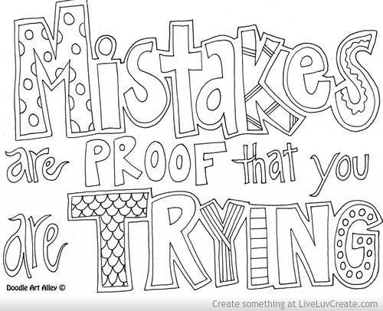
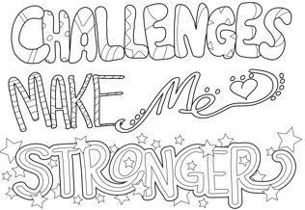

THIRD GRADE I CAN MATH STATEMENTS

OPERATIONS AND ALGEBRAIC THINKING
Represent and solve problems involving multiplication and division
3.OA.1 I can interpret products of whole numbers.
3.OA.2 I can interpret quotients of whole numbers.
3.OA.3 I can use multiplication and division within 100 to solve word problems using models, arrays, equal groups, and measurement quantities.
3.OA.4 I can solve for the unknown within a multiplication and division equation.
Understand properties of multiplication and the relationship between multiplication and division.
3.OA.5a I can apply the commutative property of multiplication. (6X4=24, 4X6=24)
3.OA.5b I can apply the associative property of multiplication. (3X5X2, 3X5=15, 15X2=30)
3.OA.5c I can apply the distributive property of multiplication. (Knowing that 8X5=40 and 8X2=16, one can find 8X7 as 8X(5+2)=(8X5)+(8X2)=40+16=56.
3.OA.6 I can understand division as an unknown-factor problem. (32/8=?, ?X8=32)
Multiply and divide within 100
3.OA.7 I can use strategies to fluently multiply and divide within 100. (Fact families, properties of operation, and memorization of all products of two one digit numbers.)
Solve problems involving the four operations, and identify and explain patterns in arithmetic.
3.OA.8 I can solve two-step word problems using addition, subtraction, multiplication, and division.
3.OA.8a I can solve two step word problems by representing unknown quantities with a letter. (5+n=7, 5Xn=35, 5-n=1, 35/n=7)
3.OA.8b I can assess the reasonableness of answers using mental computation and estimation strategies including rounding.
3.OA.9 I can identify arithmetic patterns and explain patterns using properties of operations. (addition and multiplication tables)

NUMBER AND OPERATIONS IN BASE TEN

Use place value understanding and properties of operations to perform multi-digit arithmetic.
3.NBT.1 I can use place value understanding to round whole numbers to the nearest 10 or 100.
3.NBT.2 I can use strategies and algorithms to fluently add and subtract numbers within 1000.
3.NBT.3 I can use strategies to multiply one digit numbers by multiples of 10 in the range 10-90. (9X80)

NUMBERS AND OPERATIONS-FRACTIONS
Develop understanding of fractions as numbers.
3.NF 1 I can understand a fraction as the quantity formed by one part of a whole that is partitioned into equal parts.
3.NF.2 I can understand a fraction as a number on the number line.
I can recognize the fractional interval on a number line from 0 to 1.
I can mark the fractional interval on a number line from 0 to 1.
3.NF.3a I can explain equivalence of fractions in special cases.
3.NF.3b I can compare fractions by reasoning about their size.
I can understand two fractions as equivalent (equal) if they are the same size, or the same point on a number line.
I can recognize and generate simple equivalent fractions by using a visual fraction model. (1/2=2/4)
I can express whole numbers as fractions.
I can recognize fractions that are equivalent to whole numbers. (4/4=1)
I can compare two fractions with the same numerator by reasoning about their size.
I can compare two fractions with the same denominators by reasoning about their size.
I can recognize that comparisons are valid only when the two fractions refer to the same whole.
I can use a visual fraction model to record the results of comparisons with >, <, = and justify the conclusions.

MEASUREMENT AND DATA

Solve problems involving measurement and estimation of intervals of time, liquid volumes, and masses of objects.
3.MD.1a I can tell and write time to nearest minute and measure time intervals in minutes.
3.MD.1b I can solve word problems involving addition and subtraction of time intervals in minutes.
3.MD.1c I can represent word problems on a number line diagram.
3.MD.2 I can measure and estimate liquid volumes and masses of objects using standard units of grams (g), kilograms (kg), and liters (l). I can add, subtract, multiply, and divide to solve one-step word problems involving masses or volumes that are given in the same units by using drawings to represent the problem.

Represent and interpret data.
3.MD.3a I can draw a scaled picture graph and bar graph to represent a data set with several categories.
3.MD.3b I can solve one and two “how many more” and “how many less” problems using information presented in scaled bar graphs.
3.MD.4 I can generate measurement data by measuring lengths using rulers marked with halves and fourths of an inch. I can show the data by making a line plot where the horizontal scale is marked off in appropriate units-whole numbers, halves, or quarters.
Geometric measurement: understand concepts of area and relate area to multiplication and to addition.
3.MD. 5 I can recognize area as an attribute of plane figures and understand concepts of area measurement.
3.MD.5a I can show that I understand that a square with side lengths one unit, called “a unit squared” is said to have “one square unit” of area, and can be used to measure area.
3.MD.5b I can show that I understand that a plane figure which can be covered without gaps or overlaps by n unit squares is side to have an area of n square units.
3.MD.6 I can measure areas by counting unit squares (square cm, square m, square in, square ft, and improvised units.)
3.MD.7 I can relate area to the operations of multiplication and addition.
3.MD.7a I can find the area of a rectangle with whole number side lengths by tiling it and show that the area is the same as would be found by multiplying the side lengths.
3.MD.7b I can multiply side lengths to find areas of rectangles with whole number side lengths in the context of solving real world and mathematical problems.
3.MD.7c I can represent whole number products as rectangular areas in mathematical reasoning.
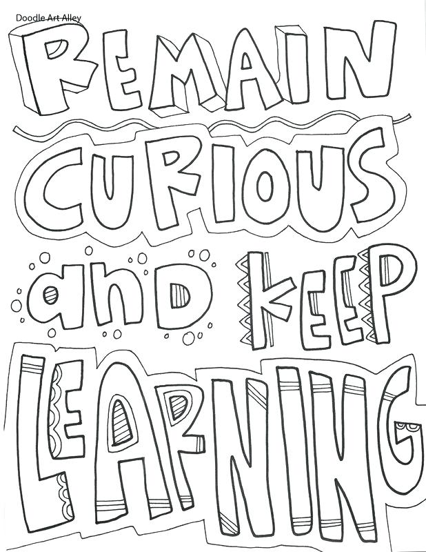
3.MD.7d I can use tiling to show in a concrete case that the area of a rectangle with whole numbers side lengths a and b + c is the sum of a X b and a X c.
3.MD.7e I can use area models to represent the distributive properties in mathematical reasoning.
3.MD.7f I can recognize area as additive.
3.MD.7g I can decompose an area of a rectangular figure into non-overlapping rectangles.
3.MD.7h I can then add the areas of the non-overlapping parts to the decomposed rectangular figure.
3.MD.7i I can apply these techniques to solve real world problems.
Geometric measurement: recognize perimeter as an attribute of plane figures and distinguish between linear and area measures.
3.MD.8a I can solve real world and mathematical problems involving perimeters of polygons, including the perimeter given the side lengths.
3.MD.8b I can find an unknown side length.
3.MD.8c I can solve real world and mathematical problems exhibiting rectangles with the same perimeter and different areas or vice versa.

GEOMETRY

Reason with shapes and their attributes.
3.G.1a I can understand that shapes in different categories may share attributes.
3.G.1b I can understand that shared attributes can define a larger category. (e.g. quadrilaterals)
3.G.1c I can recognize and draw examples of quadrilaterals. (rhombuses, rectangles, and squares)
3G.1d I can recognize and draw examples of quadrilaterals that do not belong to any of these subcategories.
3.G.2a I can partition shapes into parts with equal areas.
3.G.2b I can express the area of each part as a unit fraction of the whole.

THIRD GRADE I CAN ELA STATEMENTS
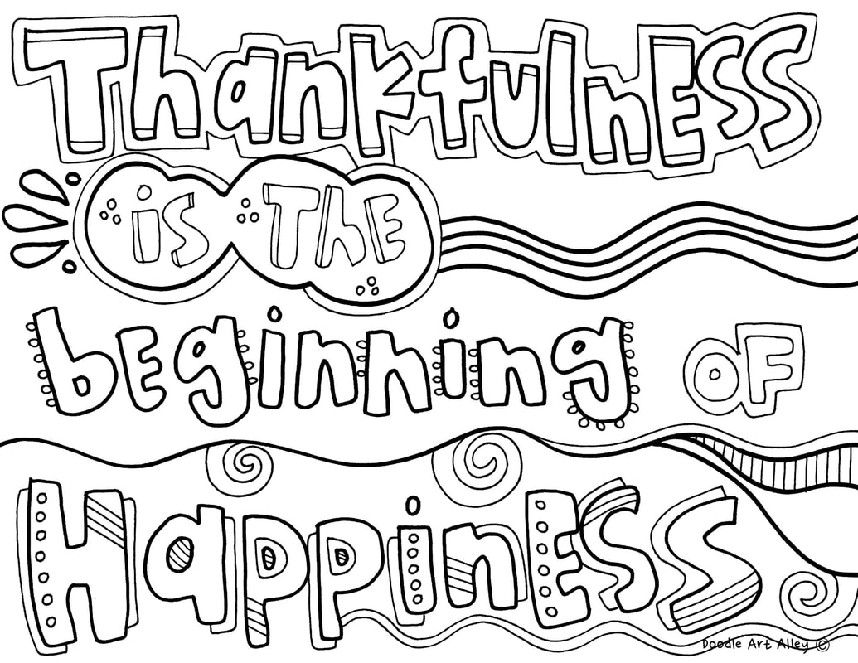
Reading – Foundational Skills
I can read words by using what I know about letters and sounds
I can show what I have learned about letters and sounds by figuring out words
I can find and tell the meanings of most common prefixes
I can find and tell the meanings of most common suffixes
I can read words with common Latin suffixes
I can read words with more than one syllable
I can read third grade words that aren’t spelled the way they sound
I can read and understand books at my level well
I can fluently read and understand books at my level well
I can read and understand third grade books
I can read third grade books and poems aloud fluently, like a teacher does
I can use what I understand from my reading to help me figure out or correct words I am having trouble with

Reading – Literature
I can read, understand, and talk about fiction stories
I can ask questions to show I understand the stories that I am reading
I can answer questions to show that I understand the stories I am reading
I can find the answers to specific questions within the stories that I read
I can remember and retell different kinds of stories from many cultures
I can figure out the lessons or morals of the stories that I read and explain that message using details from the story
I can describe characters in stories and explain how their actions affect the story
I can figure out the meanings of words or groups of words in stories by thinking about how they are used
I can tell the difference between literal and non-literal language when I read
I can write and talk about fiction by using the words for the different parts (ex: chapter, scene, stanza)
I can describe how new parts of fiction stories build on the parts that already happened
I can tell the difference between what I think and what the author or characters think in a story
I can explain how the author uses illustrations to help the meaning in a story
I can compare and contrast stories written by the same author about the same or similar characters
I can read and understand third grade stories, plays, and poems independently

Reading – Non-fiction and Informational Text
I can read, understand, and talk about non-fiction texts
I can ask questions to show that I understand the information I am reading
I can answer questions to show I understand the information I am reading
I can find the answers to specific questions within informational text that I read
I can figure out the main idea of informational text that I read
I can talk about the most important details in the information I read and how these details support the main idea
I can describe how some historical events are related to each other
I can describe how the steps in a set of directions are related to each other
I can figure out the meanings of words and phrases in science and social studies texts
I can use the parts of a text that stand out (chapter & section titles, bold words, etc.) to find information quickly
I can use search tools on the computer to find information quickly
I can tell the difference between my opinions and what an author writes in informational texts
I can show what I have learned from informational texts and illustrations by answering questions about where, when, why, and how
I can describe how the sentences and paragraphs in informational text are connected and follow a logical order
I can compare and contrast the most important ideas and details in two pieces of information about the same topic
I can read and understand 3rd grade informational texts independently

Writing
I can create different types of writing for different reasons
I can write to share my opinion and give reasons to support that opinion
I can write my opinion piece in an organized way with an introduction followed by reasons to support my opinion
I can give logical reasons that support my opinion in my writing
I can use linking words to connect my opinion with my reasons (ex: because, therefore, since, for example, etc.)
I can write a conclusion (ending) to my opinion piece
I can write clearly to inform and explain ideas to others
I can write an informative text that introduces my topic and then group related information together
I can include illustrations to help others understand my topic better
I can write about a topic using facts, definitions, and details
I can use linking words to connect the ideas in my writing (ex: also, another, and, more, but, etc.)
I can write conclusions (endings) to my informative pieces of writing
I can write organized stories that have lots of details
I can write stories from different points of view that have characters and a plot
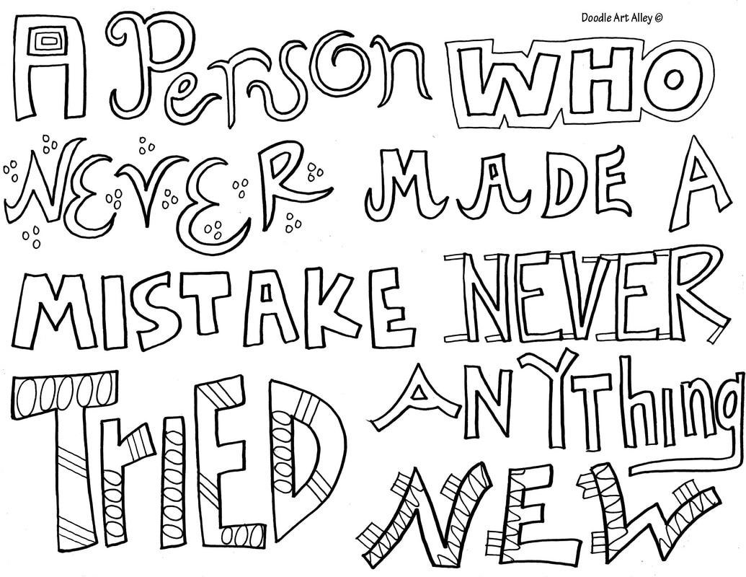
I can use dialogue between the characters in my stories
I can describe the actions and feelings of characters in my stories to help others understand the plots of the stories
I can use time order (temporal words) to help others understand the order in my stories (first, next, then, finally, etc.)
I can write logical conclusions (endings) to my stories
I can stay focused and organized in all different types of writing
I can write for different purposes, audiences, and topics

I can make my writing better and get it ready for others to read
I can plan, revise, and edit my writing with the help of friends and adults
I can use technology to create and publish my writing
I can use technology to communicate and work with others

I can use research to learn more about a topic and present it to others
I can do short research projects to help me learn more about a topic
I can remember what I have learned to help me with my research
I can find new information from books or technology to help me with my research
I can take notes to help me organize the research in my writing
I can write for short times or over a longer period of time depending on my purpose, audience, and topic

Speaking and Listening
I can have and understand conversations with all kinds of people
I can be successful when I participate in discussions
I can come to discussions prepared to share my ideas because I have read or studied what I needed to
I can listen, wait until it’s my turn to speak, and be respectful of others when I am having discussions
I can ask questions to help me understand and stay on topic when I have discussions
I can ask questions during discussions to help me to connect my ideas with other people’s ideas
I can explain my own thinking and ideas after a discussion
I can figure out the main ideas and details of what I see and hear
I can ask and answer questions about what a speaker says so that I understand and can talk more about the topic
I can share my ideas and what I have learned
I can give a report to help others understand a topic better
I can share a story or experience with important details to help others understand a topic better
I can speak clearly and at an appropriate speed when I am speaking in front of others
I can create engaging recordings of stories or poems to show my fluency in reading
I can create visual presentations to help me share facts and details better
I can speak in complete sentences to make what I am sharing more clear to others
Language – Proper English
I can use proper English when I write and speak
I can show that I know how to use words correctly when I write and speak
I can explain how parts of speech (nouns, pronouns, verbs, adjectives, and adverbs) work in different sentences
I can correctly say, write, and use all kinds of plural nouns
I can understand and use abstract nouns (those that I can’t see or touch – ex: childhood, honesty, courage, faith)
I can correctly say, write, and use all kinds of verbs (action words)
I can correctly say, write, and use different verb tenses (ex: I walked; I walk; I will walk)
I can make sure that all my nouns and verbs go together correctly in the sentences I say and write
I can make sure that all my pronouns and the nouns they refer to go together correctly in the sentences I say and write
I can correctly use comparative and superlative adjectives and adverbs correctly when I talk and write
I can use conjunctions in the correct way when I talk and write (ex: for, and, nor, but, or, yet, so, if, etc.)
I can say and write simple, compound, and complex sentences
I can show that I know how to write sentences correctly
I can use capital letters correctly when I write titles
I can use commas correctly in addresses
I can use commas and quotation marks correctly when I write dialogue between two people or characters
I can use apostrophes correctly to show possession
I can spell commonly used words correctly and add suffixes to them if needed
I can use patterns I know and rules I have learned to help me spell new words
I can use a dictionary or other resources to check and correct my spelling

I can use what I know about language in different situations
I can write, speak, read, and listen by using what I know about the English language
I can choose interesting words and phrases to help others understand my meaning better
I can recognize differences between my speaking language and my written language

I can figure out what words mean and use them in different situations
I can figure out what words mean by thinking about what I have read and by using the strategies I have learned
I can use clues from what I understand in a sentence to help me figure out new words
I can use prefixes and suffixes that I know to help me understand the meanings of new words
I can use root words I know to help me understand the meanings of new words
I can use print and online dictionaries to help me find the meanings of new words
I can show that I understand figurative language (ex: busy as a bee; slow as a snail; you are what you eat)
I can figure out how words are related and how their meanings might be similar
I can tell the differences between literal and non-literal language when I read
I can find real-life connections between words and the way they are used (ex: people who are friendly or helpful)
I can figure out the small differences in meaning with related words to tell about how people feel or how they are acting (ex: knew, believed, suspected, heard, wondered)
I can use the new words and phrases I have learned in different ways to show I know what they mean

QUARTERLY REFLECTIONS
QUARTER 1
Celebrations
1. _______________________________________________
2. _______________________________________________
3. _______________________________________________
Personal Goals
1. _______________________________________________
2. _______________________________________________
3. _______________________________________________

QUARTER 2
Celebrations
1. _______________________________________________
2. _______________________________________________
3. _______________________________________________
Personal Goals
1. _______________________________________________
2. _______________________________________________
3. _______________________________________________
QUARTERLY REFLECTIONS
QUARTER 3
Celebrations
1. _______________________________________________
2. _______________________________________________
3. _______________________________________________
Personal Goals
1. _______________________________________________
2. _______________________________________________
3. _______________________________________________

QUARTER 4
Celebrations
1. _______________________________________________
2. _______________________________________________
3. _______________________________________________
Personal Goals
1. _______________________________________________
2. _______________________________________________
3. _______________________________________________

