THIRD GRADE MATH VOCABULARY WORDS FOR PARENTS
Learning correct math vocabulary is the first step in mastering math skills and understanding the concepts. Have your student rephrase the definition in their own words; that is, how they would explain the meaning to a friend, sibling, or you. Your student should also include a diagram or drawing of the term along with the definition because math is a visual subject.
WORD |  |  | DEFINITION |  |  |  |  |  | EXAMPLE
Angle |  |  | A geometric figure consisting of two rays that share a common endpoint. The common endpoint is called the vertex. Angles are measured with a protractor, and the units are expressed in degrees. |  |  |  |  |  | Types of angles:
Area |  |  | The amount of square units it takes to cover a geometric figure. Area is inside of a two-dimensional object, and the units are expressed in square units.
Associative Property |  |  | The grouping of the numbers being added or multiplied changes, but the result is the same. |  |  |  |  |  | (2 + 3) + 4 = 2 + (3 + 4)  (2 x 3) x 4 = 2 x (3 x 4)
Commutative Property |  |  | The order of the numbers being added or multiplied can be switched but the sum or product stays the same. |  |  |  |  |  | 3 + 5 = 5 + 3  3 x 5 = 5 x 3
Congruent |  |  | Exactly the same in every way. |  |  |  |  |  | 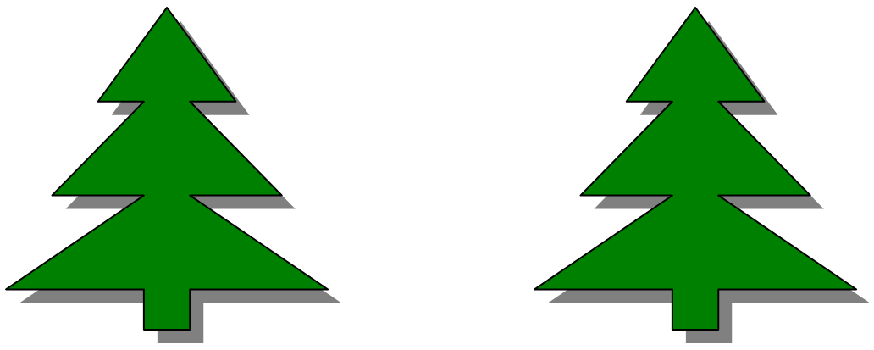
Denominator |  |  | The bottom number or expression of a fraction that often represents the whole portion, when comparing part of a whole. |  |  |  |  |  | In the fraction 2/3, 3 is the denominator.
Distributive Property |  |  | Allows you to multiply each term in a parentheses and then add as the final operation |  |  |  |  |  | 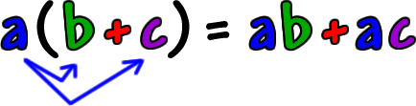
Dividend |  |  | The value being divided into in a division problem. |  |  |  |  |  | 12 ÷ 4 = 3
Divisor |  |  | The value being divided by in a division problem. |  |  |  |  |  | 12 ÷ 4 = 3
Equation |  |  | A mathematical sentence that states that two expressions are equal in value.
Factors |  |  | Numbers that divide evenly into a number and do not leave a remainder. |  |  |  |  |  | The factors of 12 are 1, 2, 3, 4, 6, and 12
Fraction |  |  | A number that is used to express a ratio, often as part of a whole. A fraction is made up of a numerator and a denominator. |  |  |  |  |  | 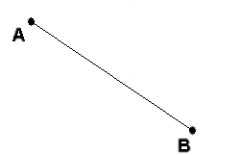  In the fraction 5/16, 5 is the numerator and 16 is the denominator.
Line |  |  | A straight path that continues in both directions forever.
Line Segment |  |  | Part of a line – it is two points on a line and all the points between them.
Multiple |  |  | A whole number that another whole number divides into without remainder. |  |  |  |  |  | Some multiples of 6 are 6, 12, 18, and 24.
Numerator |  |  | The top number or expression in a fraction. Often, it represents the part when comparing a part to a whole. |  |  |  |  |  | In the fraction 5/7, 5 is the numerator.
Order of Operations |  |  | An agreed upon order of how to perform the basic math operations so that answers are consistent. |  |  |  |  |  | MDAS (My Dear Aunt Sally) = Multiplication, then Division, then Addition, then Subtraction
Parallel Lines |  |  | Two lines in the same plane that will never intersect or cross.
Perimeter |  |  | The distance around a geometric shape. Perimeter is found by adding the lengths of all the sides of a geometric polygon.
Perpendicular Lines |  |  | Lines that intersect at right angles.
Place Value |  |  | Where a digit is in a number determines its value (how much it is worth) |  |  |  |  |  | 555=500+50+5
Product |  |  | The answer to a multiplication problem. |  |  |  |  |  | 3 x 4 = 12
Quadrilateral |  |  | A four-sided closed geometric figure. |  |  |  |  |  | 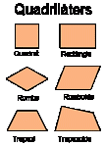
Quotient |  |  | The answer to a division problem. |  |  |  |  |  | 12 ÷3 = 4
Sum |  |  | The answer to an addition problem. |  |  |  |  |  | 3 + 4 = 7
Triangle |  |  | A geometric figure with three sides; this is one of the most important of the geometric figures. The right angle, which contains one right angle, is used in both measurements and in trigonometry. |  |  |  |  |  | 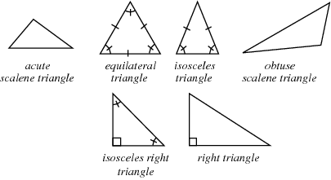
Unit |  |  | A linear measure; it is a part of a line used to measure the length of something. |  |  |  |  |  | 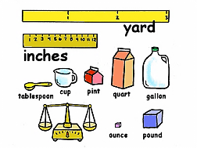
Variable |  |  | An unknown value, usually represented by a letter of the alphabet. |  |  |  |  |  | n + 10 = 15  n = 5
Key Terms and Phrases
Math is a language that uses numbers and symbols, and common terms and phrases appear in math problems to represent the four basic operations and equivalence. Look for the key words and convert them into math symbols that can be worked with to find a final answer.
Operation |  | + |  |  | - |  | x |  |  | ÷ |  | =
Key  Words |  | Add  Sum  Increased by  More than  Plus  Exceeds |  |  | Subtract  Difference  Decreased by  Less than  Minus  Reduced by |  | Multiply  Product  Of  Times |  |  | Divide  Quotient  Into  Split |  | Equal  Result  Is  Total
Steps to Solving Problems
By breaking down the process of solving a problem into smaller pieces, you can solve big problems more easily. Often, you do these steps unconsciously. Work with your child to instill these habits.
Step 1  Determine what is the question asking for? | Step 2  What is the given information (what do we know)? |  |  | Step 3  Do you know or remember a similar problem? |  | Step 4  What is the plan?  Can you estimate an answer? |  | Step 5  Carry out the plan – all attempts to solve the problem will lead to some understanding. |  |  | Step 6  Look back and forward – did you answer the question, is the answer reasonable? What did you learn?

