COMMUNITY AND CULTURE

THIRD GRADE SOCIAL STUDIES:

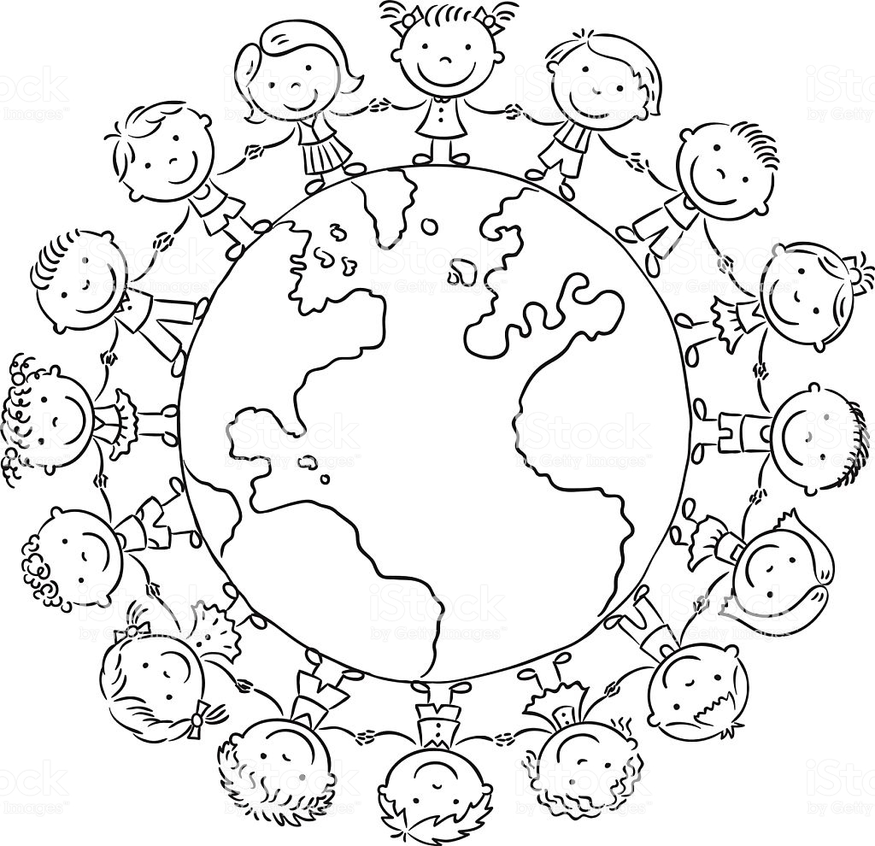
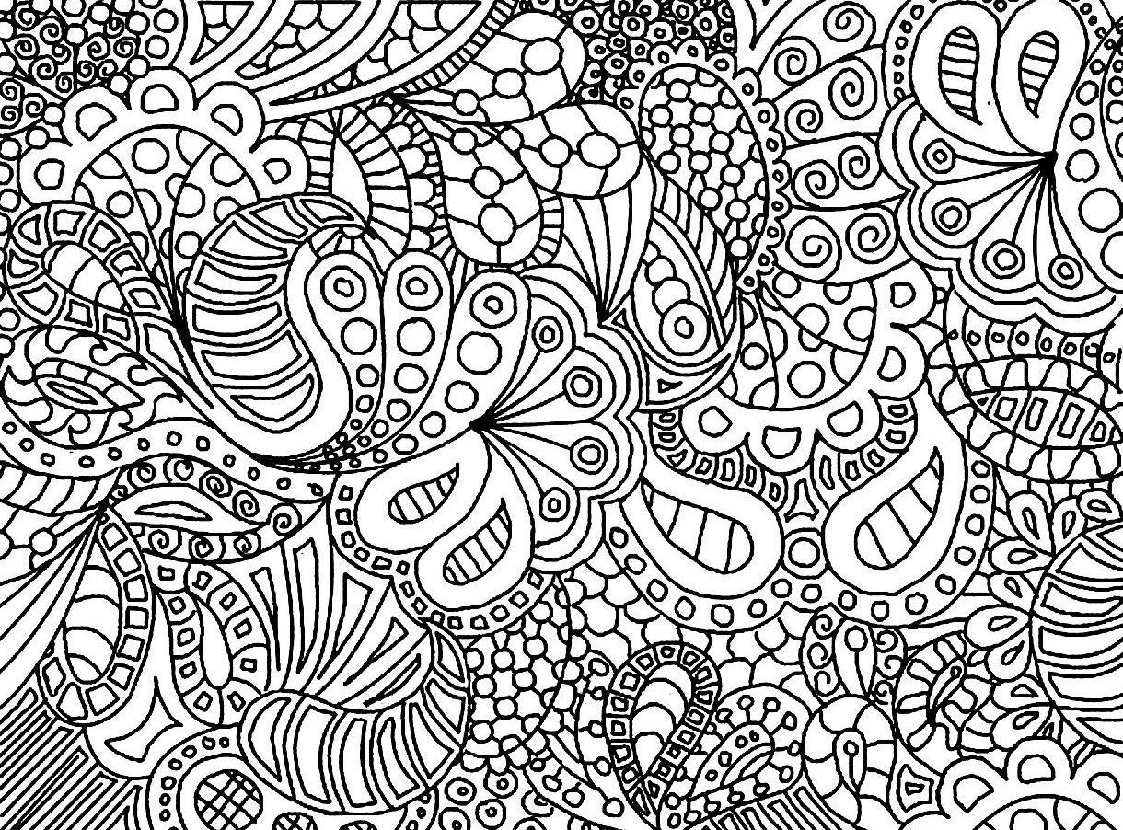
Name: ______________________________
Homeroom Teacher: ____________________
In the third grade, students will explore the concept of community, learning about the development of cultures, systems of governance, how communities and cultures interconnect both locally and globally, and how the world around them has changed over time. Students will learn about individual rights and responsibilities as well as opportunities for active participation in the life of the community.
While the primary focus is on the local community, students will also learn more about the larger world. Geographic skills development will result from comparisons of local communities with communities both near and far. Students will learn more about the geography and richness of indigenous communities and their cultures both in the Americas and around the world.
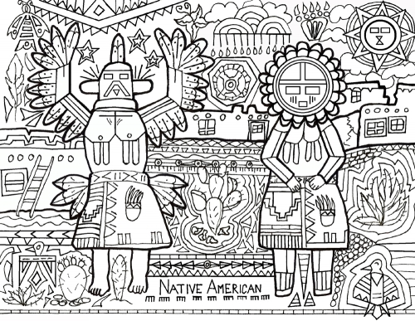
Third graders should begin to use historical thinking skills and the interpretation of primary sources. Local resources, including newspapers and other primary sources could serve to further develop the awareness of the many parts of a community.
The most important goal: A well-lived life
Excitement, wonder, inquiry, delight, and puzzlement are central to meaningful learning in social studies. Social studies should be fun and intriguing for all students and provide opportunities to make important life-long connections between the past, present, and future. Students who appreciate the sacrifices that have been made in the past and understand the challenges that lie ahead can make better decisions in the present.
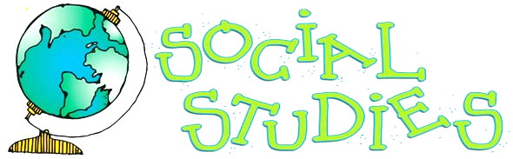
STANDARD I: Students will understand how geography influences community location and development.
BENCHMARK: The geography of a community influences the cultural development of the humans who inhabit the community. There are relationships between climate, natural resources, and other geographic characteristics and a community’s cultural development. The unique characteristics of an area influence where and how communities develop, their relative wealth and power, and how they adapt to changes.
OBJECTIVE 1: Determine the relationships between human settlement and geography.
Indicators:
- Identify the geographic features common to areas where human settlements exist.
- Use map features to make logical inferences and describe relationships between human settlement and physical geography
- Compare the shapes and purposes of natural and human-made boundaries of cities, counties, and states.
OBJECTIVE 2: Describe how various communities have adapted to existing environments and how other communities have modified the environment.
Indicators:
- Describe the major world ecosystems (i.e. desert, plain, tropic, tundra, grassland, mountain, forest, and wetland).
- Identify important natural resources of world ecosystems.
- Describe how communities have modified the environment to accommodate their needs
- Investigate ways different communities have adapted into an ecosystem.
OBJECTIVE 3: Analyze ways cultures use, maintain, and preserve the physical environment.
Indicators:
- Identify ways people use the physical environment (e.g. agriculture, recreation, energy, industry).
- Compare changes in the availability and use of natural resources over time.
- Describe ways to conserve and protect natural resources
- Compare perspectives of various communities toward the natural environment.
- Make inferences about the positive and negative impacts of human-caused change to the physical environment.
VOCABULARY WORDS:
Latitude, longitude, compass rose, north, south, east, west, continents, ocean, key, equator, desert, plain, tropic, tundra, grassland, mountain, forest, wetland, natural resources, reduce, reuse, recycle, recover, economic development, community development, recreation, natural resource extraction, agriculture
STANDARD II: Students will understand cultural factors that shape a community.
BENCHMARK: All people exist within cultures, or the way of life a group of people. All human communities have cultural attributes. These attributes change over time in response to changes in the world around them. Indigenous cultures in North and South America demonstrate these attributes.
OBJECTIVE 1: Evaluate key factors that determine how a community develops.
Indicators:
- Identify the elements of culture (e.g. language, religion, customs, artistic expression, systems of exchange).
- Describe how stories, folktales, music, and artistic creations serve as expressions of culture.
- Compare elements of the local community with communities from different parts of the world (e.g. industry, economic specialization).
- Identify and explain the interrelationship of the environment (e.g. location, natural resources, and climate) and community development (e.g. food, shelter, clothing, industries, markets, recreation, and artistic creations).
- Examine changes in communities that can or have occurred when two or more cultures interact.
- Explain changes within communities caused by human inventions (e.g. steel plow, internal combustion engine, television, and computer).
OBJECTIVE 2: Explain how selected indigenous cultures of the Americas have changed over time
Indicators:
- Describe and compare early indigenous people of the Americas (e.g. Eastern Woodlands, Plains, Great Basin, Southwestern, Arctic, Incan, Aztec, and Mayan).
- Analyze how these cultures changed with the arrival of people from Europe and how the cultures of the Europeans changed.
- Identify how indigenous people maintain cultural traditions today.
VOCABULARY WORDS:
Indigenous cultures, American Indian, Eastern Woodlands, Plains, Great Basin, Southwestern, Arctic, language, religion, customs, artistic expression, Europe, economic specialization, exchange systems, markets

Name: _____________________________________________________________________
STANDARD 1 PRETEST – this is a pretest. It’s okay if you don’t know the answers!
Vocabulary words:
Latitude, longitude, compass rose, north, south, east, west, continents, ocean, key, equator.

Write the correct vocabulary word in the spaces below. 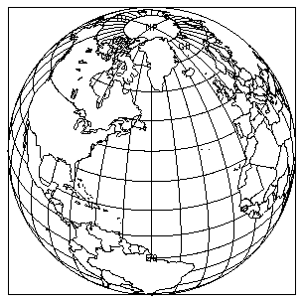

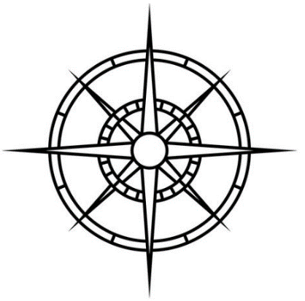
Name: ________________________________
STANDARD 1 PRETEST – this is a pretest. It’s okay if you don’t know the answers!
Vocabulary words:
Latitude, longitude, compass rose, north, south, east, west, continents, ocean, key, equator.

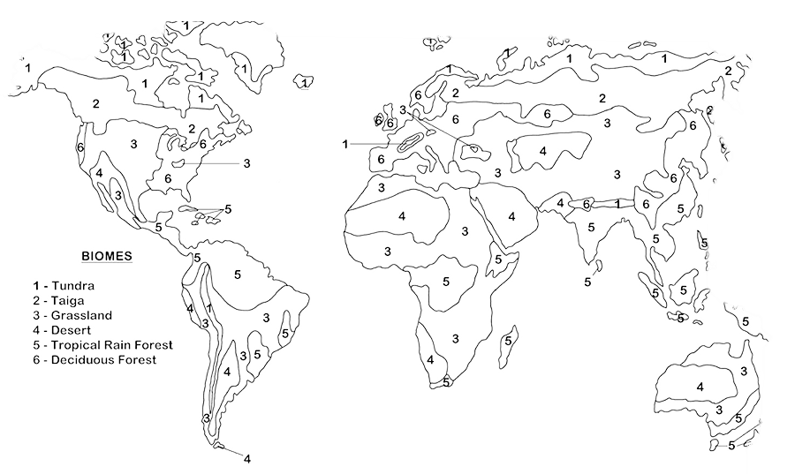
What are these? Write the correct vocabulary word in the rectangles.
Name: __________________________________
NOTES ON “MAPS AND HOW TO READ THEM”:
- How many elements do good maps have? _________
- What is the first thing EVERY map SHOULD have? A _________________
- Why is a Compass Rose called that? _________________________________________________________
- Scale shows the ratio between a unit of length on the map and a unit of ______________ on the earth.
- Are there different kinds of maps? _________
- Are there REALLY lines on the ground to show where states or countries are? ________
DRAW A MAP OF YOUR NEIGHBORHOOD BELOW. BE SURE TO INCLUDE YOUR HOUSE!

Name: _____________________________________________________________________
STANDARD 1 POST TEST
Vocabulary words:
Latitude, longitude, compass rose, north, south, east, west, continents, ocean, key, equator.

Write the correct vocabulary word in the spaces below.

Name: ________________________________
STANDARD 1 POST TEST
Vocabulary words:
Latitude, longitude, compass rose, north, south, east, west, continents, ocean, key, equator.

What are these? Write the correct vocabulary word in the rectangles.
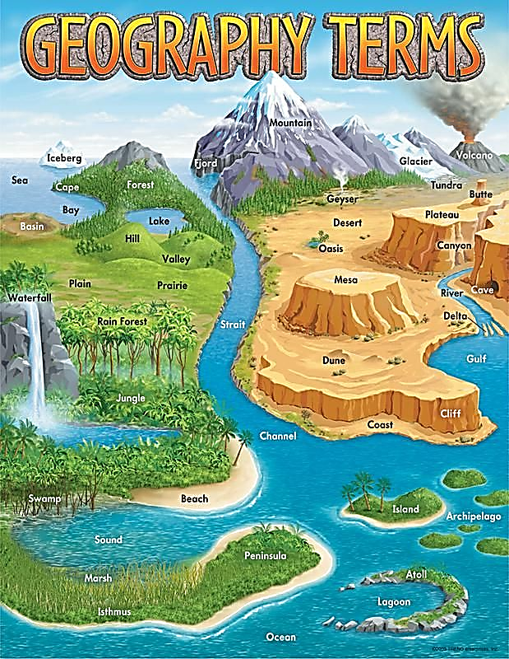
Name: __________________________________
NOTES ON “GEOGRAPHIC FEATURES AND HOW GEOGRAPHY INFLUENCES COMMUNITY LOCATION AND DEVELOPMENT”
- Geographic features can be both on the _______________________ and on the _______________________________________
- What do people need to survive? Food, shelter, water, air, ___________
- ADAPTING means adjusting to the environment with creativity and ____________. MODIFYING is using technology to _______________ the environment to suit you.
- Do you think adapting or modifying is better for the planet? ________
- What makes a Plain different from Grasslands? Plains are ___________
- What is the dominant feature in the Tropics? The _________________
- What makes a Grassland? _________________________________
- How many types of Forests are there? _________________________
- Coniferous forests have _________________, Temperate forests have ___________________________ trees, and Tropical rainforests have ___________________________ of rain and high temperatures.
- Which wetland is forested? A _______________________________.

WORD BANK FOR NATURAL RESOURCES CHART:
Oil and Natural Gas  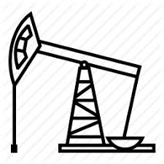 | Minerals | Medicine | Diamonds and other gems
Wheat, corn,  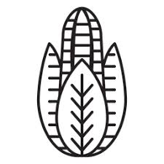 | Iron ore, copper | Oxygen and wood  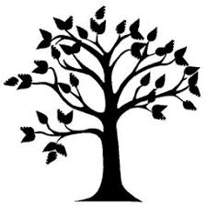 | Fish  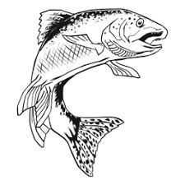
Name: __________________________________
What NATURAL RESOURCES would you find in each landform?
LANDFORM | NATURAL RESOURCES
Deserts
Plains
Tropics
Tundra
Grasslands
Mountains
Forests
Wetlands
Name: ____________________________

Name: ______________________________________
NOTES ON “NATURAL AND HUMAN-MADE BOUNDARIES”
- A physical boundary is a _____________________ occurring divide between two areas. These are ___________ human-made; they are part of nature.
- Physical boundaries can come in geographical forms such as bodies of water, mountains, and _______________________.
- Political boundaries are the officially drawn dividing lines between __________________, states and cities.
- Can you see political boundaries from space? __________________
- Political boundaries can form along ____________________ boundaries.
- Do political boundaries change? _____________________
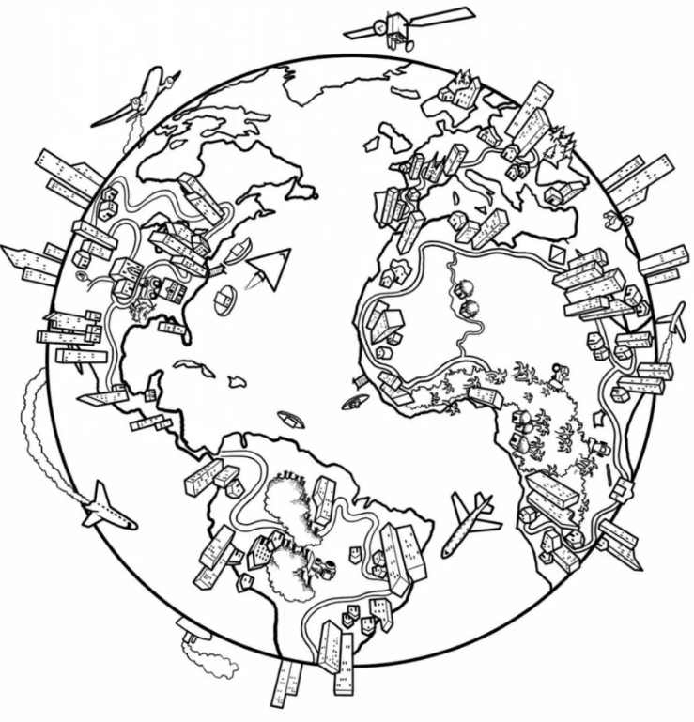
- Why would two countries fight over borders? A natural __________________ both groups want, or in an attempt to gain political ____________________

Name: _____________________________________
NOTES ON “A CLOSER LOOK AT FORESTS”
- Cutting down trees directly impacts the ___________________ environment.
- Are the Earth’s environments connected? _______________
- Is it ALWAYS bad to cut down a tree? __________________
- What is ONE effect of cutting down LOTS of trees? _____________________
- What percentage of people have experienced impacts from climate change? __________
- Who knows best how to protect forests? _____________________________
- Native Americans believe in the Tree of ___________ and __________ Trees.
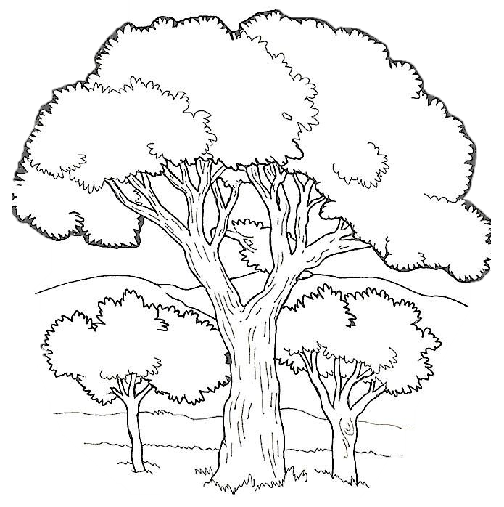
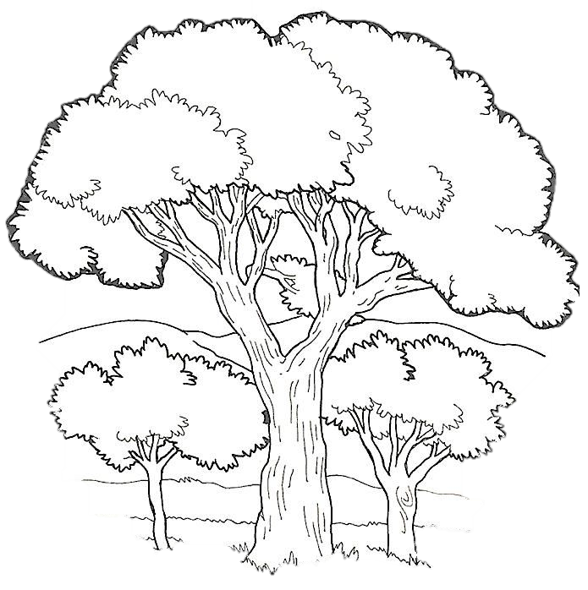
- What is one thing YOU can do to protect trees? __________________________________________________________________________________________________________________

Name: _____________________________________
NOTES ON “HOW DO PEOPLE USE, MAINTAIN, AND PRESERVE THE PHYSICAL ENVIRONMENT?”
- How do people USE the physical environment? Agriculture, Energy, Recreation and ____________________________________
- We took a closer look at _____________________________________
- Fossil fuels allow us to power our homes, businesses, and machines with coal, oil, and __________________
- What does “finite” mean? It will ___________________________________
- What is ONE way to conserve and protect natural resources? ______________
- How many bison were there in 1750? _______ million.
- Native American hunters used ____________________ of the buffalo.
- What kind of problem did the White settlers have? An ___________________ problem.
- Bison went from 80 million animals to ___________________ single animals.
- Would you call the population of American Bison a SUCCESS story? _________

Name: ___________________________________________
NOTES ON STANDARD II: STUDENTS WILL UNDERSTAND CULTURAL FACTORS THAT SHAPE A COMMUNITY
- The elements of culture are: language, religion, _______________________, artistic expression, and systems of exchange.
- What is your favorite way to show your culture – stories, folktales, music, or artistic creation? _____________________________________________
- Folk tales teach us what is _______________________________ in cultures.
- What is the title of the story you were given? _________________________________________________________ What do you think the story tries to teach you? _________________________________________________________
Compare/Contrast the two Cinderella stories:
Rough Faced Girl
You Tube version
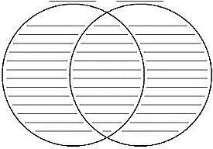
Name: ______________________________________
NOTES ON “HOW THE SMARTPHONE HAS CHANGED YOUR COMMUNITY”
Do you think children under 10 should have their own cell phone? Why or why not? Include at least 3 reasons why you feel the way you do.
________________________________________________________________________________________________________________________________________________________________________________________________________________________________________________________________________________________________________________________________________________________________________________________________________________________________________________________________________________________________________
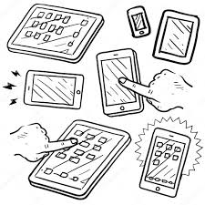
_______________________________________________________________________________________________________________________________________________________________________________________

Name: __________________________________________

Name of the Nation: INUIT
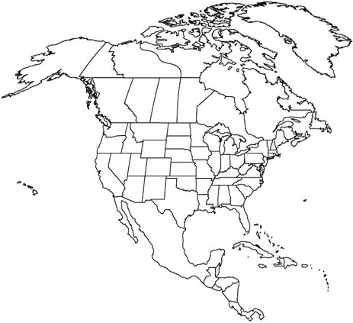
Territory (where their traditional homeland is)

Elements of their culture:

________________________________________________________________________________________________________________________________________________________________________________________________________________________________________________________________________________________________________________________________________________________________________________________________________

Traditional food:
____________________________________________________________________________________________________________

Unique features of this Nation:

________________________________________________________________________________________________________________________________________________________________________________________________________________________________________________________________________________________________________________________________________________________________________________________________________Traditional homes: Traditional clothing:
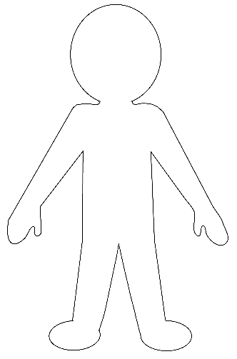

Name: __________________________________________

Name of the Nation: INCAN
Territory (where their traditional homeland is)

Elements of their culture:

________________________________________________________________________________________________________________________________________________________________________________________________________________________________________________________________________________________________________________________________________________________________________________________________________

Traditional food:
____________________________________________________________________________________________________________

Unique features of this Nation:

________________________________________________________________________________________________________________________________________________________________________________________________________________________________________________________________________________________________________________________________________________________________________________________________________Traditional homes: Traditional clothing:

Name: __________________________________________

Name of the Nation: AZTEC
Territory (where their traditional homeland is)

Elements of their culture:

________________________________________________________________________________________________________________________________________________________________________________________________________________________________________________________________________________________________________________________________________________________________________________________________________

Traditional food:
____________________________________________________________________________________________________________

Unique features of this Nation:

________________________________________________________________________________________________________________________________________________________________________________________________________________________________________________________________________________________________________________________________________________________________________________________________________Traditional homes: Traditional clothing:

Name: __________________________________________

Name of the Nation: MAYAN
Territory (where their traditional homeland is)

Elements of their culture:

________________________________________________________________________________________________________________________________________________________________________________________________________________________________________________________________________________________________________________________________________________________________________________________________________

Traditional food:
____________________________________________________________________________________________________________

Unique features of this Nation:

________________________________________________________________________________________________________________________________________________________________________________________________________________________________________________________________________________________________________________________________________________________________________________________________________Traditional homes: Traditional clothing:

Name: __________________________________________

Name of the Nation: SIOUX
Territory (where their traditional homeland is)

Elements of their culture:

________________________________________________________________________________________________________________________________________________________________________________________________________________________________________________________________________________________________________________________________________________________________________________________________________

Traditional food:
____________________________________________________________________________________________________________

Unique features of this Nation:

________________________________________________________________________________________________________________________________________________________________________________________________________________________________________________________________________________________________________________________________________________________________________________________________________Traditional homes: Traditional clothing:

Name: __________________________________________

Name of the Nation: CHEROKEE
Territory (where their traditional homeland is)

Elements of their culture:

________________________________________________________________________________________________________________________________________________________________________________________________________________________________________________________________________________________________________________________________________________________________________________________________________

Traditional food:
____________________________________________________________________________________________________________

Unique features of this Nation:

________________________________________________________________________________________________________________________________________________________________________________________________________________________________________________________________________________________________________________________________________________________________________________________________________Traditional homes: Traditional clothing:

Name: __________________________________________

Name of the Nation: IROQUOIS
Territory (where their traditional homeland is)

Elements of their culture:

________________________________________________________________________________________________________________________________________________________________________________________________________________________________________________________________________________________________________________________________________________________________________________________________________

Traditional food:
____________________________________________________________________________________________________________

Unique features of this Nation:

________________________________________________________________________________________________________________________________________________________________________________________________________________________________________________________________________________________________________________________________________________________________________________________________________Traditional homes: Traditional clothing:

Name: __________________________________________

Name of the Nation: TLINKIT
Territory (where their traditional homeland is)

Elements of their culture:

________________________________________________________________________________________________________________________________________________________________________________________________________________________________________________________________________________________________________________________________________________________________________________________________________

Traditional food:
____________________________________________________________________________________________________________

Unique features of this Nation:

________________________________________________________________________________________________________________________________________________________________________________________________________________________________________________________________________________________________________________________________________________________________________________________________________Traditional homes: Traditional clothing:

Name: ____________________________

NOTES ON “HOW DID NATIVE CULTURES CHANGE WITH THE ARRIVAL OF PEOPLE FROM EUROPE?”

- When did Spaniards first contact the Chumash? ______________________
- How long have the Chumash lived in California? ______________________
- How many Chumash were living in 1900? ___________________________
- Who apologized for the genocide? ________________________________

HOW DO INDIGENOUS PEOPLE KEEP THEIR CULTURAL TRADITIONS ALIVE TODAY?
- How many federally recognized tribes and villages are there? _____________
- _______________________ Native communities were completely wiped out.
- In boarding schools, many _____________________ died from malnutrition.
- A new native generation is taught to live with dignity, character, and _________
- Young people may find their place through listening to __________________
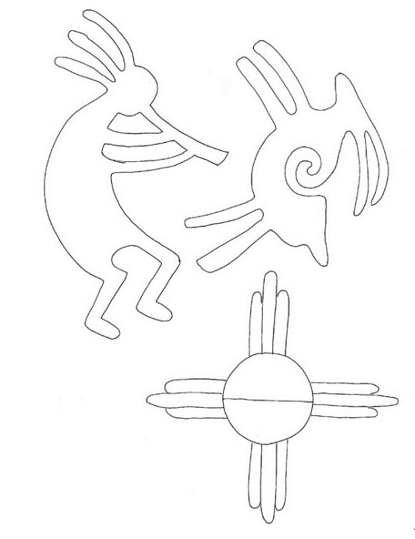
- Participating in Ceremonies: Pow Wows, Sweats, _______________________

